Static array and dynamic array : Static arrays have a fixed size determined at compile-time and are typically stored on the stack, whereas dynamic arrays have a flexible size that can grow or shrink at runtime and are stored on the heap..

Characteristics of Static Arrays

Immutability: Once defined, the capacity is permanent. If you need more space than originally allocated, you must create a new, larger array and manually copy data over

Characteristics of Dynamic Arrays

Automatic Resizing: Most modern implementations (like Python's list or C++'s std::vector) double in capacity when they become full.
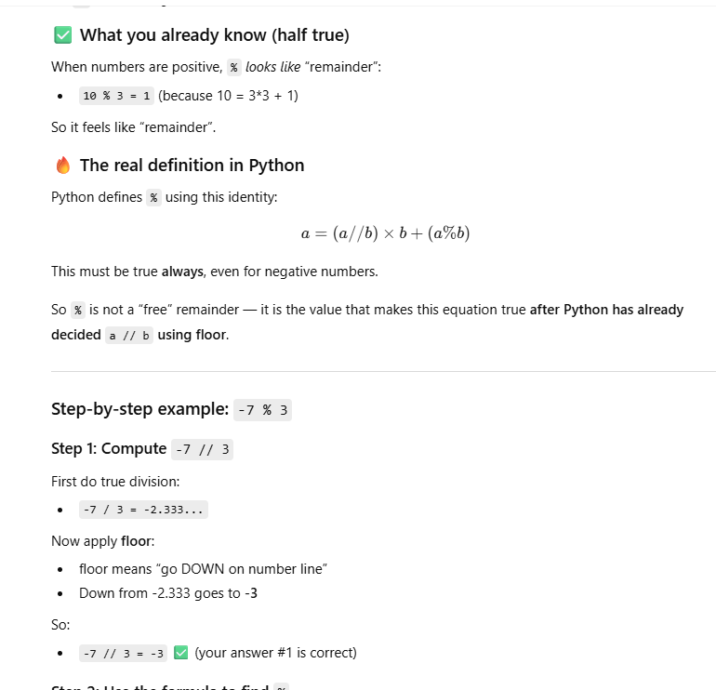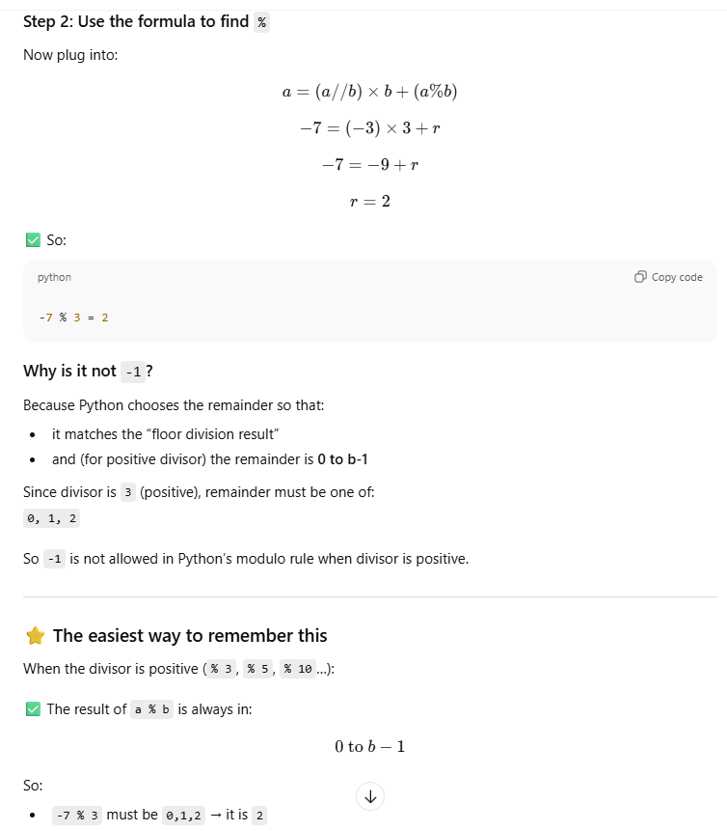

String Comparison in PYTHON:
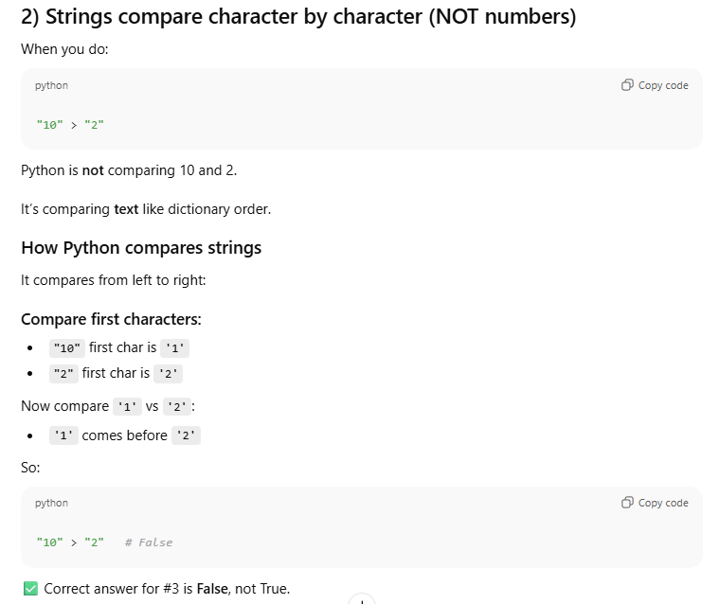

ERRORS:
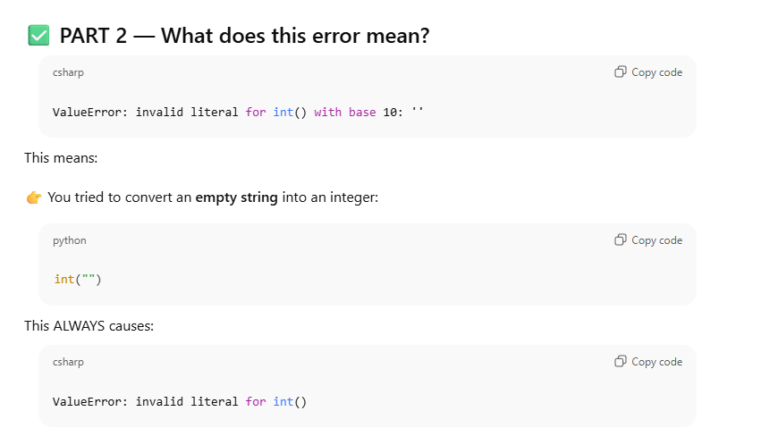

DICT METHODS & LAMBDA EXPRESSIONS, LIST COMPREHENSION:
1) sorted vs .sort
- sorted(iterable, key=..., reverse=...) → returns a new list. Works on any iterable (list, set, dict, generator, …). Does not modify the original.
- list.sort(key=..., reverse=...) → in-place sort of an existing list. Returns None.
Same algorithm (Timsort), same time O(m log m) for m items.

2) What does key=... do?
Think “decorate → sort → undecorate”:
- For each element x in the iterable, Python computes key(x) once.
- It sorts the elements using those key values.
- It returns the elements themselves in that order.
Examples you’ll use all the time:
- sorted(words, key=len) → by length
- sorted(pairs, key=lambda kv: kv[1]) → by tuple’s second item
- sorted(names, key=str.casefold) → case-insensitive
- Top-K frequent trick: sorted(freq, key=freq.get, reverse=True)
Dict iteration yields keys; freq.get(k) gives that key’s count. So this sorts keys by their counts.
Concrete mini-trace:
freq = {1:3, 2:5, 7:2}
sorted(freq, key=freq.get, reverse=True)
# keys are 1,2,7; key values are 3,5,2 → order by (5,3,2) → [2,1,7]
The key idea is: sorted iterates over its first argument. When that first argument is a dict, iterating it yields its keys by default

sorted(freq, key=freq.get) # iterate dict → keys
sorted(freq.keys(), key=freq.get) # explicit keys
sorted(freq.items(), key=lambda kv: kv[1]) # (key, value) pairs, sort by value

3) Lambda: tiny, one-line functions
- Syntax: lambda x: <expression using x>
- Use in key=..., map, filter, or anywhere a short function is handy.
If lambdas feel fuzzy, define a normal function and pass it:
def by_count(k): return freq[k]
sorted(freq, key=by_count, reverse=True)

4) Comprehensions: build a new collection from an iterable
- List: [expr for x in it if cond]
- Dict: {k(x): v(x) for x in it if cond}
- Set: {expr for x in it if cond}
Same result as a loop + append/assign; just shorter and often clearer.
Examples:
# extract the first k keys after sorting pairs by count
pairs = [(2,5), (1,3), (7,2)]
topk = [k for (k, _) in pairs[:2]] # → [2, 1]

# dict comp: squares of even numbers
squares = {x: x*x for x in range(6) if x % 2 == 0} # {0:0,2:4,4:16}

5) Dict essentials you’ll use constantly
- freq.get(k, 0) → fetch with default (great for counting).
- freq.items() → (key, value) pairs.
- freq.keys() / freq.values() → views of keys/values.
- setdefault(k, default) or defaultdict(list) → painless grouping (e.g., anagrams).
  - In anagrams: key is something immutable like tuple(sorted(word)).

6) Same thing, three ways (top-k frequent)
Assume freq = {1:3, 2:5, 7:2}, k=2.
A. Sort keys by counts (no lambda):
def by_count(x): return freq[x]
keys = list(freq)
keys.sort(key=by_count, reverse=True) # [2,1,7]
topk = keys[:k] # [2,1]

B. Sort items by value (with itemgetter):
from operator import itemgetter
pairs = list(freq.items()) # [(1,3),(2,5),(7,2)]
pairs.sort(key=itemgetter(1), reverse=True) # by count
topk = [k for k, _ in pairs[:k]] # [2,1]

C. One-liner you’ve seen:
topk = sorted(freq, key=freq.get, reverse=True)[:k] # [2,1]

Time for all three sorting approaches: O(u log u) where u = len(freq).
If k ≪ u, the min-heap alternative is O(u log k):
import heapq
topk = heapq.nlargest(k, freq.keys(), key=freq.get)

7) How to get confident fast (tiny drills)
Do these without looking, then check:
- Sort names by length (desc).
- Sort list of (name, score) by score (desc).
- From a dict {char:count}, produce the 3 highest-count chars.
- Group words by their sorted-letters key (anagrams).
- Build {word: len(word)} for words with length ≥ 4 via dict comp.

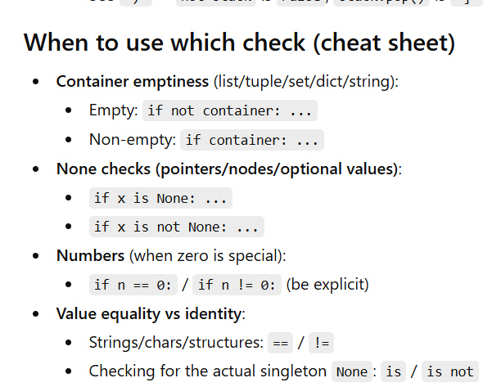

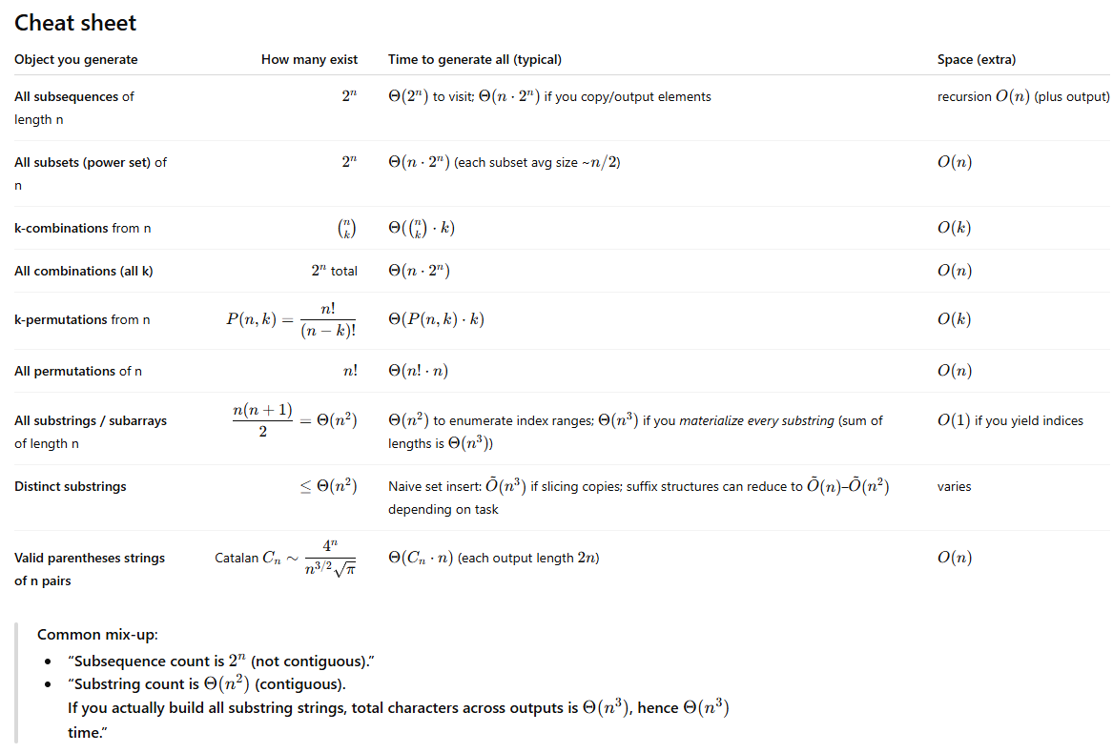

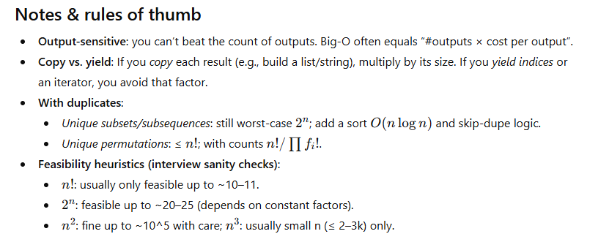
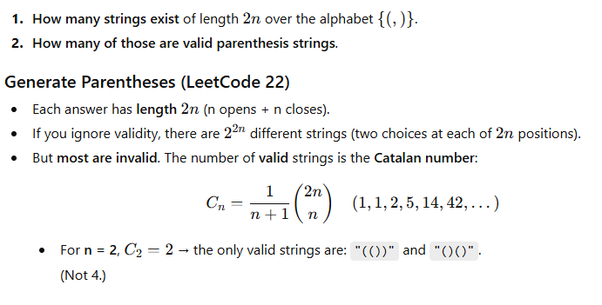
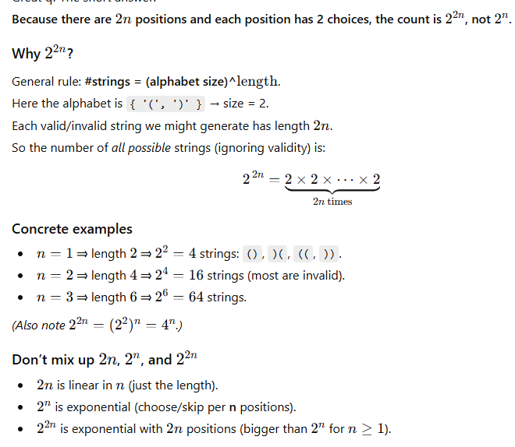
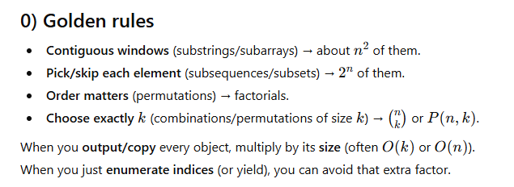

- Both substrings and subarrays must consist of elements that are consecutive in the original data structure
- Subsequence: A subsequence is a sequence that can be derived from another sequence by removing zero or more elements, without changing the order of the remaining elements.
- For the same example, there are 15 sub-sequences. They are (1), (2), (3), (4), (1,2), (1,3),(1,4), (2,3), (2,4), (3,4), (1,2,3), (1,2,4), (1,3,4), (2,3,4), (1,2,3,4). More generally, we can say that for a sequence of size n, we can have (2n-1) non-empty sub-sequences in total.
A string example to differentiate: Consider strings "geeksforgeeks" and "gks". "gks" is a subsequence of "geeksforgeeks" but not a substring. "geeks" is both a subsequence and subarray. Every subarray is a subsequence. More specifically, Subsequence is a generalization of substring.
- A subarray or substring will always be contiguous, but a subsequence need not be contiguous. That is, subsequences are not required to occupy consecutive positions within the original sequences. But we can say that both contiguous subsequence and subarray are the same.
- A subarray is a contiguous part of the array. An array that is inside another array.
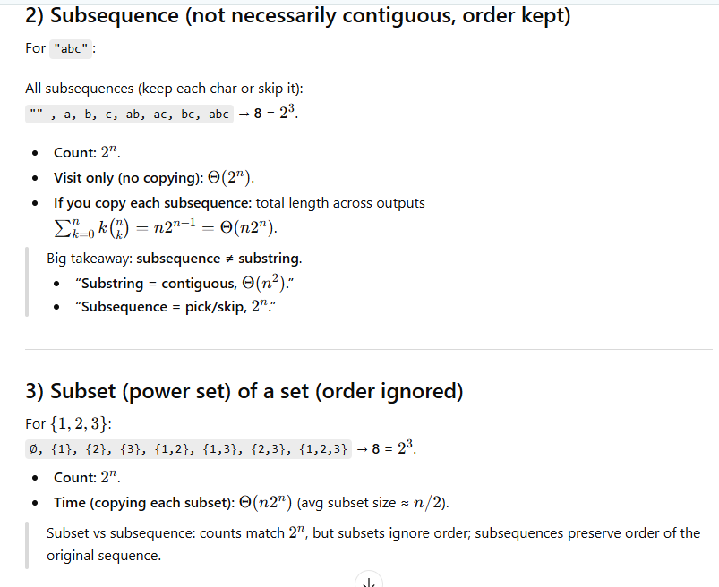

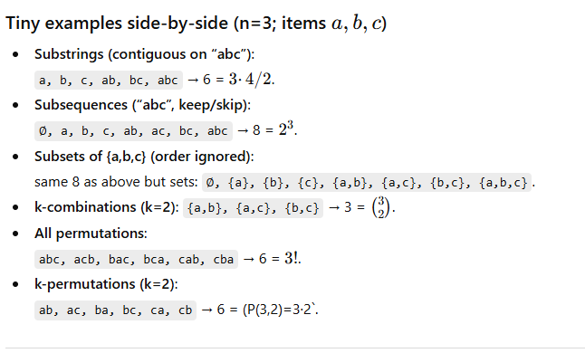

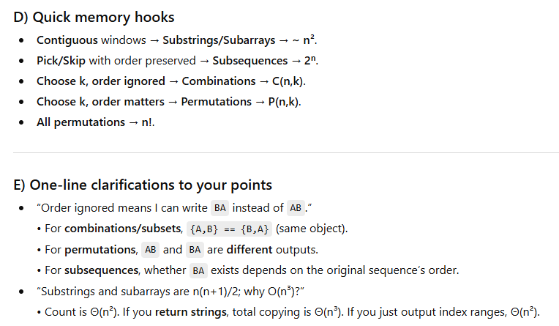

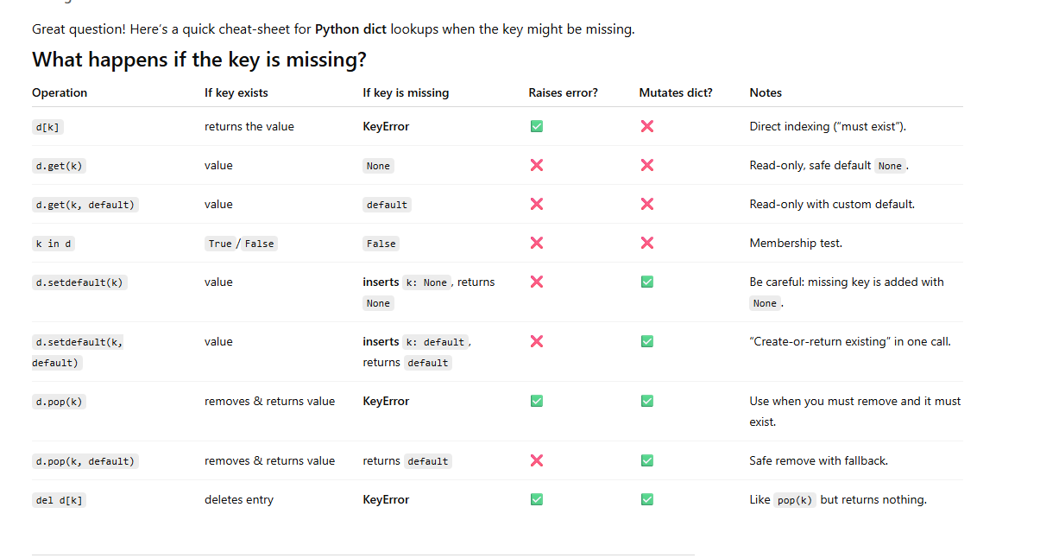

STRINGS:

  - Loop + string concatenation → bad (O(n²)).
  - Loop + list.append → good (O(n)).
- You don’t need to “avoid a loop” entirely—you just need to avoid concatenating strings in the loop. Gather pieces, then join once.
Rule of thumb:
If you’re building a long string from many pieces, use a list (or builder) + one final join. That gives you overall O(n) time.
The appendleft() method is used with a collections.deque object in Python to add an element to the left end (front) of the deque.

split(" ") splits only on a single space and keeps empty strings when there are multiple spaces.
Example: "a good example".split(" ") → ['a', 'good', '', '', 'example']
LinkedList: Not contiguous memory , you can increase/decrease the size of the array. Used in Stack/ Queue - No Fixed Size in /stack and Queue
In real life, you always use it in a browser.
Depending on the system, memory space used is different
